

M.Sc. Thesis Research Proposal
Title
By
Name
Number

Department of Industrial Engineering and Engineering Management
College of Engineering
University of Sharjah

Supervisors
Supervisor Name

Month Yr
Abstract
Write your own abstract

Acknowledgment
Write your own acknowledgment

Table of Content

CHAPTER 1: STUDY BACKGROUND 2
1.1 Introduction 2
1.2 Problem Statement 2
1.3 Research Aim & Objectives or Research Questions 2
1.4 Study Limitations if any 2
CHAPTER 2: LITERATURE REVIEW 3
2.1 Subsection 1 3
2.2 Subsection 2 3
CHAPTER 3: METHODOLOGY 4
3.1 Subsection 1 4
3.2 Subsection 2 4
CHAPTER 4: FUTURE PLAN 5
References 6

Table of Abbreviations
Abbreviation | Meaning

CHAPTER 1: STUDY BACKGROUND
XXX

1.1 Introduction
XXX

1.2 Problem Statement
XXX

1.3 Research Aim & Objectives or Research Questions
XXX

1.4 Study Limitations if any

CHAPTER 2: LITERATURE REVIEW
XXX

2.1 Subsection 1
XXX

2.2 Subsection 2
XXX
ADD MORE SUBSECTIONS IF YOU WANT

Table ‎0-1Captions are above the tables
Col 1 | Col2 | Col 3 | Col 4

CHAPTER 3: METHODOLOGY

3.1 Subsection 1
XXXX

3.2 Subsection 2
XXX
Add more subsections

Figure 1 Captions below figures

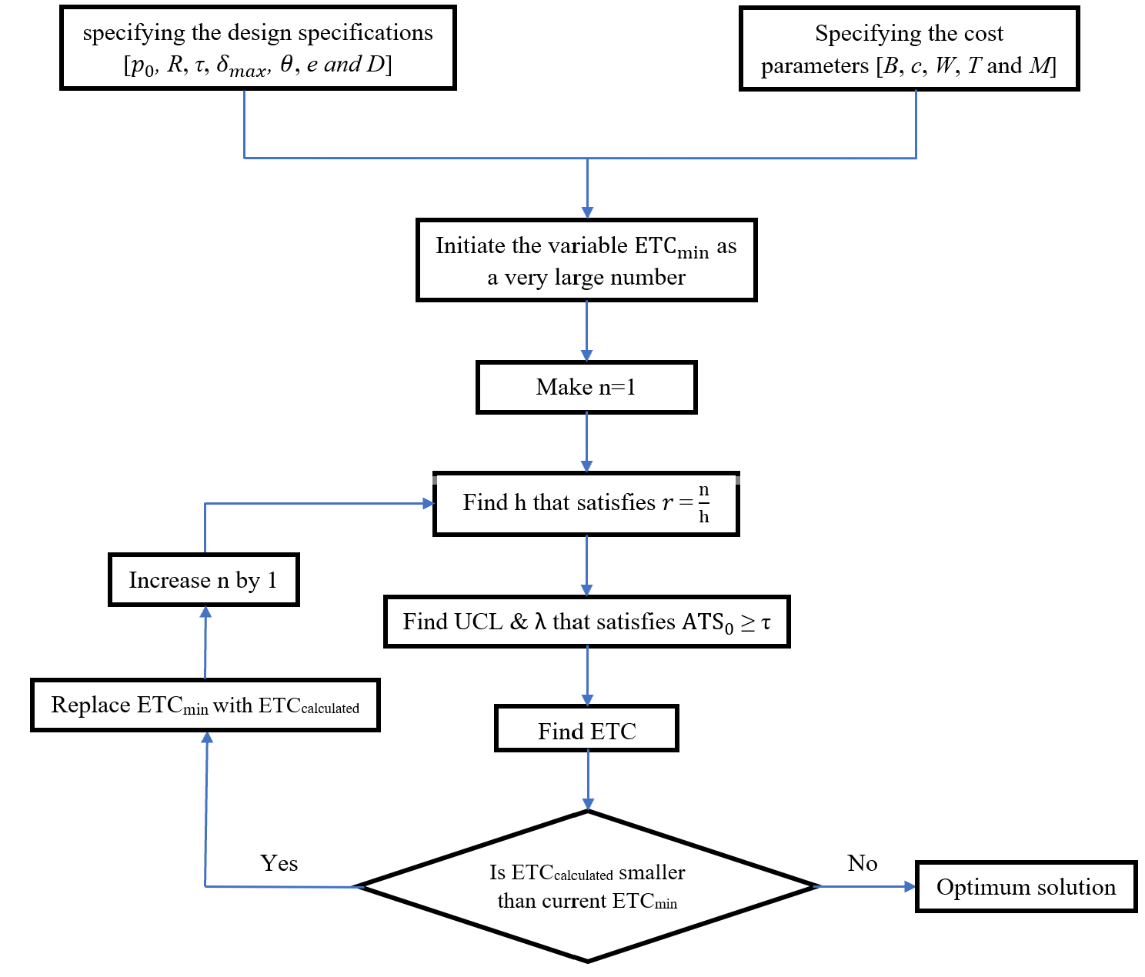
CHAPTER 4: FUTURE PLAN
Table 4.1 shows a Gantt chart that summarizes the tasks performed to fulfil the research objectives. XXXX
Table 2. A Gantt chart showing …..
Task | Oct 22 | Nov 22 | Dec 22 | Jan 23
Finish literature
Survey preparation

References
APA citation style
Al-Shihabi, S. (2016). A hybrid of max–min ant system and linear programming for the k-covering problem. Computers & Operations Research, 76, 1-11.

